**What's in Your Online Shopping Cart?**

Many industries have embraced the move to online shopping. Music, movies and books sales are predominately online, airline tickets and vacations too. Clothing, shoes and even eyewear are now finding ways of making online transactions risk-free. One of the last industries to transition to the online world of shopping carts is the original source of actual shopping carts; grocery retailers and the food industry.

Online grocery shopping is only a very small percentage of total sales for now, but the demand is growing. This growth is driven primarily by dual-income families, who value convenience over price, and millennials, who grew up online. These two groups represent both the best customers and the newest customers for the food industry, and the more we know about their shopping habits, the better we can attend their needs.

The U.S. online retailer Instacart released aggregate sales data of 3 million orders as part of a data analysis competition. Analyzing this data allows us to gain insights about the purchase patterns of their customers. Just looking at total online product sales we see that by far the largest department is produce.

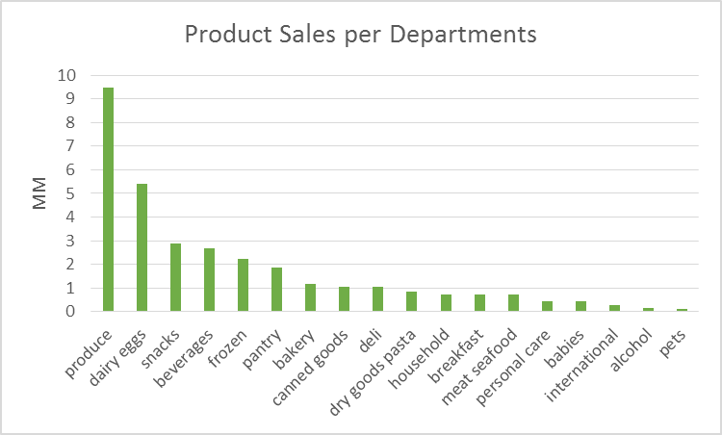

But the real insights occur when we begin to look at product combinations consumers make. There was a famous case study of grocery stores having a strong tie between the purchase of diapers and beer. The rationale being that while the mother stayed home with the child, the fathers would be sent out to buy diapers and they would treat themselves to beer.

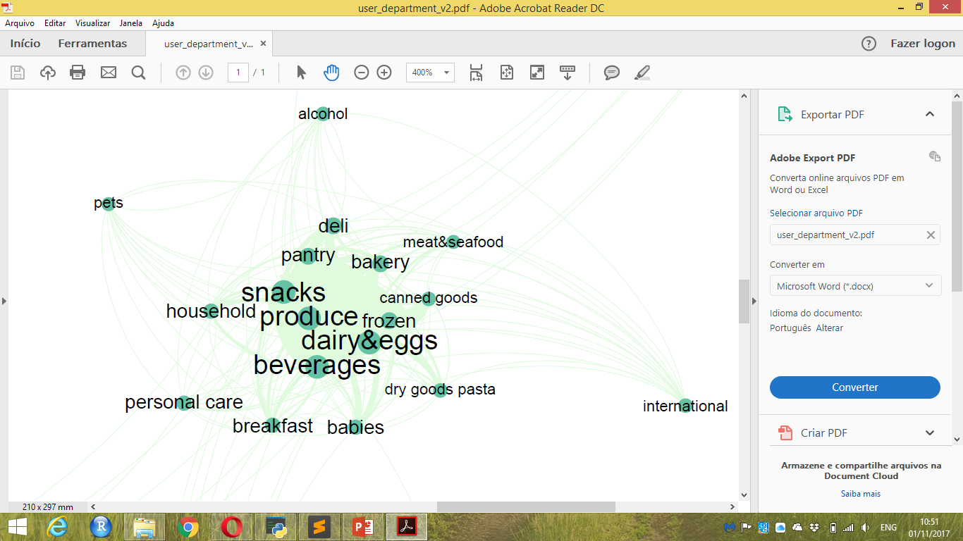With this online data, we can also graph the product combinations. In the graph A we see the names of all the different product departments, and the closer the names in the picture more likely items are purchased together. So in this case, people who ordered alcohol were more likely to have ordered deli (“fatiados”) as well, as opposed to people ordering alcohol and pet supplies. What becomes clear with this data is that people do groceries for four specific reasons: produce (“hortifruti”), snacks, dairy&eggs and beverages. These are the categories that you will find in every online shopping cart, replenishing these essentials, before possibly adding another more niche needs.

Graph A – Products from these departments were bought together (The bigger the name more items were sold)

Even more interesting, we can analyze the data even deeper within these essential departments and find another very distinct pattern. In the graph B the network is clearly divided into two subgroups. When people order bananas online they are more likely to buy organic Hass avocados, whereas when people order plates online they are more likely to order regular avocados. The idea being that when people buy for themselves they want to buy the healthier organic avocado, but when they throw a party and want to make guacamole they don't mind economizing and buying the regular avocados. We can see that people are buying for two different purposes, which I have labeled Personal Wellness, and Social Events.

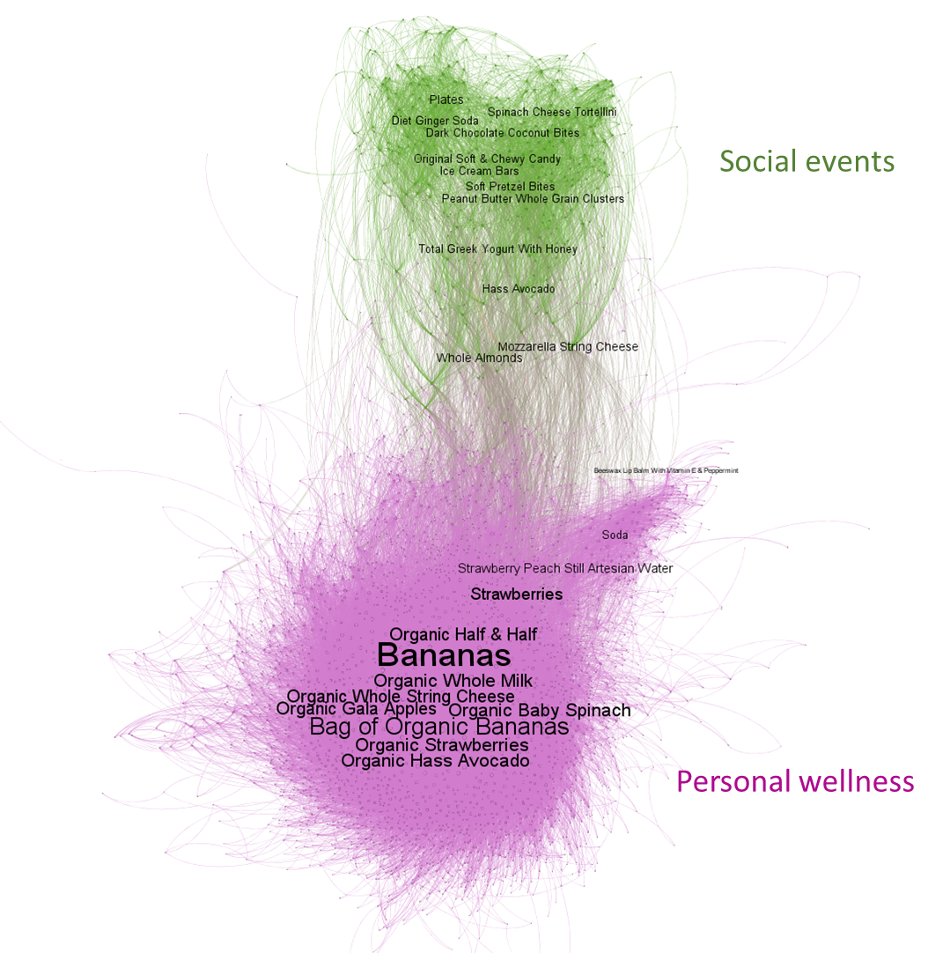

Graph B – Products that were bought together (The bigger the name more times were sold)

These are just some of the interesting observations we can see when we dig deep into the data. This shows that the food industry should look beyond its borders and closer to the consumer perspective.

***You can get the code in my github account and here are some references for further reading. Best to all!***

*Instacart Customer Experience: http://www.thekitchn.com/i-had-my-groceries-delivered-by-instacart-and-heres-how-it-went-214795*

*Instacart Data: https://tech.instacart.com/3-million-instacart-orders-open-sourced-d40d29ead6f2*

*Instacart Website: https://www.instacart.com*

*Instacart Kaggle Competition: https://www.kaggle.com/c/instacart-market-basket-analysis*

*EDA inspirations: https://www.kaggle.com/sudalairajkumar/simple-exploration-notebook-instacart*

*https://www.kaggle.com/philippsp/exploratory-analysis-instacart*

*mcKinsey experts interview on online retail*

*http://www.mckinsey.com/industries/retail/our-insights/the-future-of-grocery-in-store-and-online*